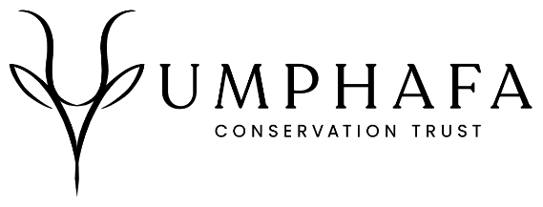
Application Form
For Internship on the UmPhafa Nature Reserve

Please complete this form if you wish to apply for an internship at the UmPhafa Nature Reserve.
The information you supply on this form will enable us to assess your application as fully as possible.

Please email your completed form to: wendy@colchesterzoo.org

Personal Details
Name: | Surname: |  | D.O.B:
Sex: |  | Nationality:

Contact Details
Street name & number
Town/City
County
Post Code
Country
Telephone
Mobile
Email

Where did you hear about this placement?

Languages
Primary
Secondary
Others
(please list with level of competency)

Please state your reasons for wishing to take part in the projects of UmPhafa

Costs for two weeks
12th May – 26th May 2026 | £800
8th September – 22nd September 2026 | £800
22nd September – 6th October 2026 | £800

(This is not a firm commitment, and you may adjust this time after an offer of placement has been made)
PLEASE NOTE: A £100 surcharge for airport transfers will be applied if no other bookings are taken during your preferred deployment date
If you are a UK tax payer, you can boost your donation by 25p for every £1 you donate.
- I am a UK taxpayer and understand that if I pay less Income Tax and/or Capital Gains Tax in the current tax year than the amount of Gift Aid claimed on all my donations it is my responsibility to pay any difference
Are you willing to participate in the strenuous physical activity required by work placements on the reserve?

Do you have any special dietary requirements? (Please specify)

