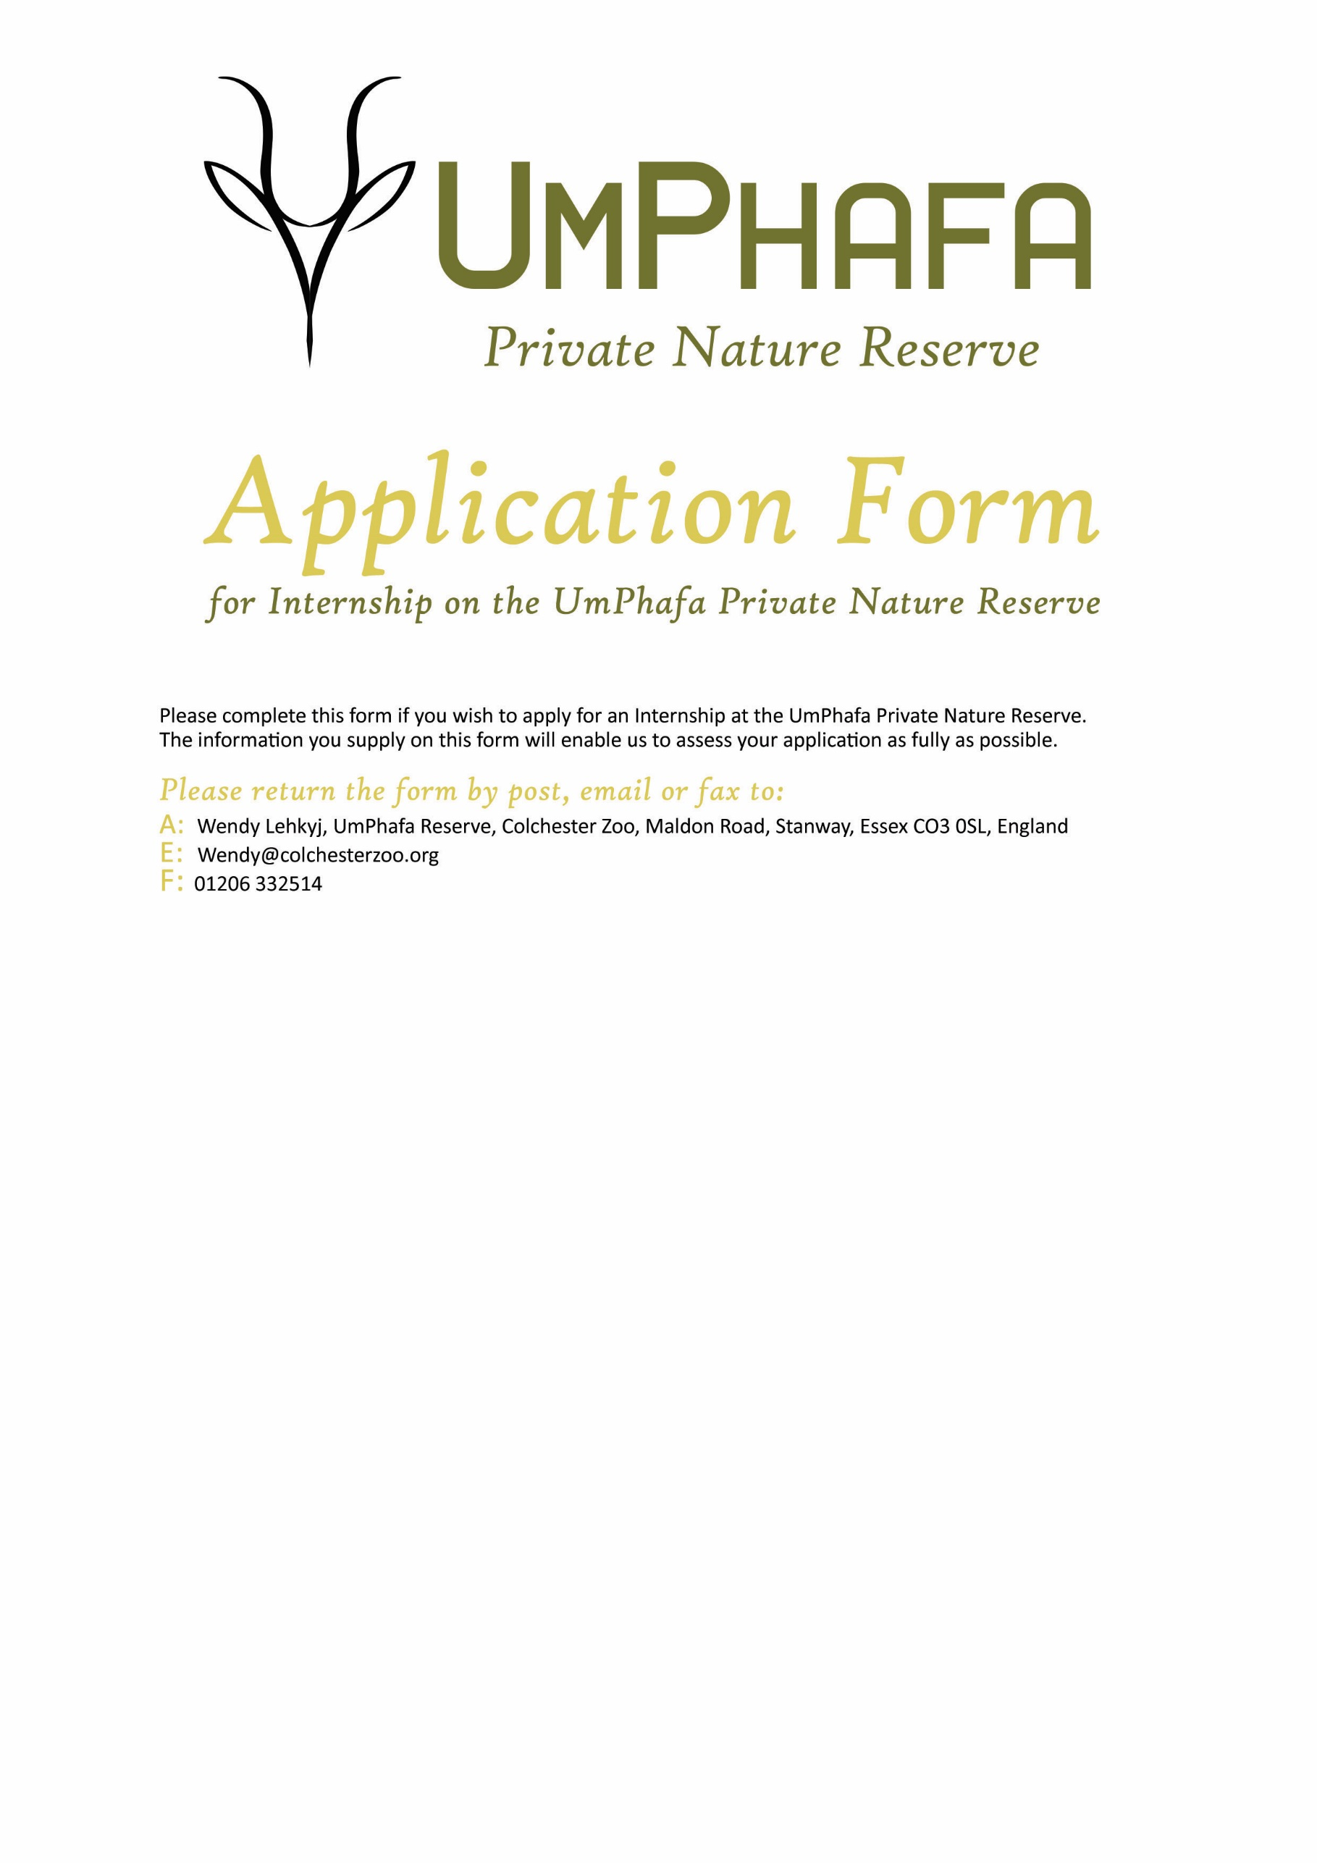

Personal Details
Name: | Surname: |  | D.O.B:
Sex: |  | Nationality:

Contact Details
Street name & number
Town/City
County
Post Code
Country
Telephone
Mobile
Email

Where did you hear about this placement?

Languages
Primary
Secondary
Others
(please list with level of competency)
Please state your reasons for wishing to take part in the projects of UmPhafa

(This is not a firm commitment, and you may adjust this time after an offer of placement has been made)
Costs for two weeks
10th September – 24th September 2024 | £800
24th September – 8th October 2024

PLEASE NOTE: A £100 surcharge for airport transfers will be applied if no other bookings are taken during your preferred deployment date
If you are a UK taxpayer, you can boost your donation by 25p for every £1 you donate.
- I am a UK taxpayer and understand that if I pay less Income Tax and/or Capital Gains Tax in the current tax year than the amount of Gift Aid claimed on all my donations it is my responsibility to pay any difference.
Are you willing to participate in the strenuous physical activity required by work placements on the reserve?

Do you have any special dietary requirements? (Please specify)

PLEASE ENSURE YOU INCLUDE A COPY OF YOUR CV WITH THIS APPLICATION FORM

