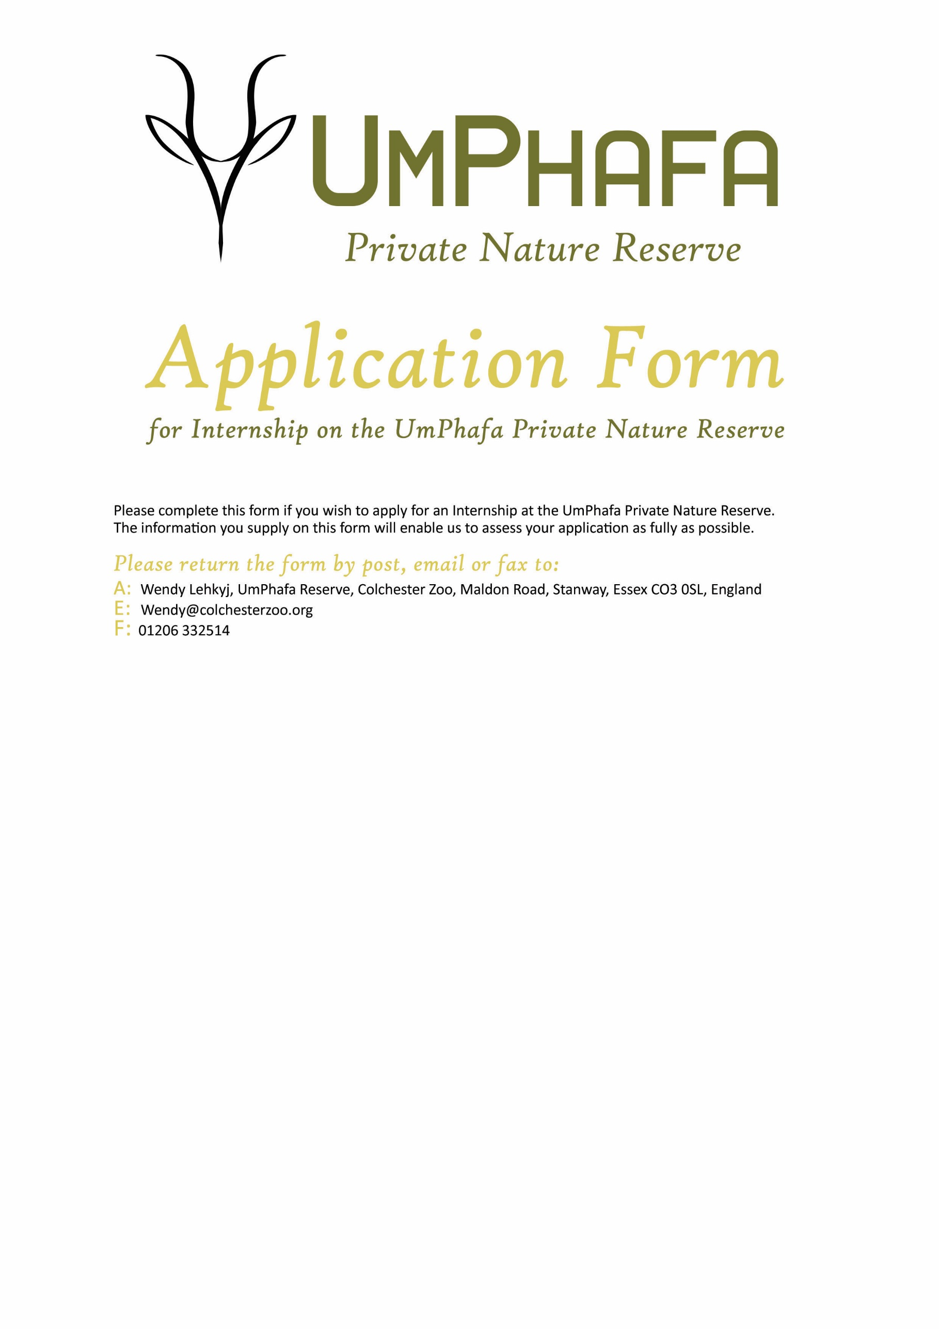

Personal Details
Name: | Surname: |  | D.O.B:
Sex: |  | Nationality:

Contact Details
Street name & number
Town/City
County
Post Code
Country
Telephone
Mobile
Email

Where did you hear about this placement?

Languages
Primary
Secondary
Others
(please list with level of competency)

Please state your reasons for wishing to take part in the projects of UmPhafa

Please indicate how much time you would be willing to dedicate to the placement
(This is not a firm commitment, and you may adjust this time after an offer of placement has been made. Longer placements are available on request at an additional £680 per four weeks)
Costs
Four Weeks | £1320
Six Weeks | £1660
Eight Weeks | £2000
Ten Weeks | £2340
Twelve Weeks | £2680

If you are a UK tax payer, you can boost your donation by 25p for every £1 you donate.
- I am a UK taxpayer and understand that if I pay less Income Tax and/or Capital Gains Tax in the current tax year than the amount of Gift Aid claimed on all my donations it is my responsibility to pay any difference
Are you willing to participate in the strenuous physical activity required by work placements on the reserve?

Do you have any special dietary requirements? (Please specify)

PLEASE ENSURE YOU INCLUDE A COPY OF YOUR CV WITH THIS APPLICATION FORM

