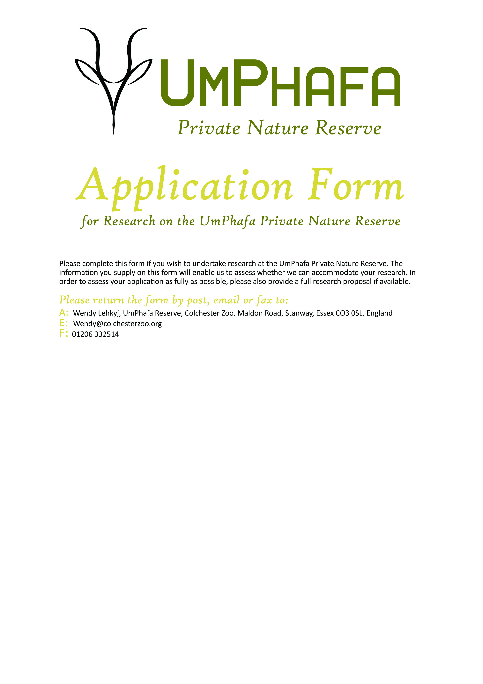

Personal details
Name: | Surname: |  | D.O.B:
Sex: |  | Nationality:

Term-time details
Address line 1
Address line 2
Address line 3
Town/City
County
Post Code
Country

Telephone
Email

Home (long-term) details
Street name & number
Town/City
County
Post Code
Country

Telephone
Email

What is the best way to contact you about your application? (e.g telephone/email/post)

Academic details
Course and level
Academic institution
Academic supervisor | Name:  T:  E:

Project details
Project title
Is this project from the list of priority topics produced by UmPhafa? | Yes / No

Project rationale (e.g. why is this research important? What is the value of this research to UmPhafa / conservation). Please continue on additional sheets if necessary.

Methods
Methodology, including pilot study, manipulations, sampling, data collection, statistics:

Support required from UmPhafa, including equipment and facilities:

Relevant reference material, e.g. books, journal articles:
1.
2.
3.
4
5.
Will you be using any specialist equipment which may require certain operating conditions?

Data collection
Proposed data collection period | DD/MM/YY – DD/MM/YY
Latest date by which you need a decision from us | DD/MM/YY
Are you willing to supply UmPhafa with a copy of your final report? | Yes / No

Costs for Research Placement – please select your preference
Four Weeks | £1220
Eight Weeks | £1840
Twelve Weeks | £2460
Other (please state)

Is there any other additional information which you feel might help us in our decision (e.g support from a recognised scientific body or organisation / involvement with other reserves)?

Where did you hear about this placement?

PLEASE ATTACH ANY OTHER ADDITIONAL INFORMATION
E.G. RESEARCH PROPOSAL/ LETTERS OF SUPPORT FROM ORGANISATIONS OR TUTORS
Applicant’s signature
Date

Supervisor’s signature*
Date
*I understand that by signing above I have agreed to supervise the project outlined in the proposal
OFFICE USE ONLY
Application received | DD/MM/YY
Copied to relevant staff | Yes / No
Decision made | Accepted / Rejected
Applicant informed of decision | Yes / No
Other comments

